ENROLMENT INFORMATION AND PROCEDURES
Chifley College Dunheved Campus
Learn Discover Inspire
Chifley College Dunheved Campus enrolment information and procedures has been developed in accordance with the Department of Education’s (DoE) Enrolment of Students in NSW Government Schools: A Summary and Consolidation of Policy (August 1997).

Chifley College Dunheved Campus has three classes in the Support Unit. Enrolment into these classes is determined by a Regional Panel. For more information about placement in a support class, contact the Principal of your current school.

General Principles Governing Enrolment
The following guidelines apply to enrolment at government schools:
- A student is considered to be enrolled when he or she is placed on the admission register of a school;
- A student should be enrolled in one school only at any given time;
- Children are entitled to be enrolled at the government school that is designated for the intake area within which the child’s home is situated and that the child is eligible to attend;
- School local areas are determined by the Department of Education;
- Parents may seek to enrol their child in the school of their choice;
- Schools are required to set an enrolment number to cater for anticipated local demand and to seek to ensure that every eligible local child has a place at his or her local school if he or she chooses to attend it;
- Schools are required to have a written policy which states the grounds on which non-local enrolments will be accepted;
- The primary criteria for acceptance of non-local enrolments will include the availability of appropriate staff and permanent classroom accommodation;
- The requirement of Work Health and Safety must be considered before any student is enrolled; and
- Students with a history of violence or criminal behaviour may not be accepted if the risk assessment reflects that the safety and wellbeing of students and staff may be comprised.

YEAR 6-7 ENROLMENTS
Enrolment Ceilings and Buffer
Each school year a ceiling is established for the enrolment of Year 7 based on available school facilities. The school maintains a ceiling of no class needing to exceed 28 students with a buffer of 2 students, except in Stage 4 Technology Mandatory, where no class needs to exceed 22 students and in Year 7 Visual Arts, where no class needs to exceed 20 students: Agreement between the NSW Department Of Education and the NSW Teachers Federation on the Staffing of NSW Public Schools 2016-2020. Each year, a buffer will be determined annually to cater for anticipated local demand from our feeder primary schools (Ropes Crossing, North St Mary’s, Oxley Park, Tregear, Whalan and Wilmot), including new local arrivals who locate to Chifley College Dunheved Campus for commencement at the beginning of the school year.

Non-Local Enrolments
Parents of students who live outside the designated enrolment area may wish to make application for their child to attend Chifley College Dunheved Campus.
The acceptance of out of area students will be dependent on several factors, including;
- meeting the requirements of the Department of Education Enrolment Policy, and
- availability of space in the school overall and within cohorts.

Criteria for Consideration of Non-Local Enrolment Applications
Criteria for considering and selecting amongst non-local enrolment applications is documented and made available to parents who are interested in enrolling their children.
Criteria (are not listed in a priority order):
- Proximity and access to the school;
- siblings already enrolled at the school;
- medical reasons;
- safety and supervision of the student (or sibling) before and after school;
- availability of subjects or combinations of subjects;
- compassionate circumstances; and
- structure and organisation of the school.
The Principal will ensure that the established criteria are applied equitably to all applications. Parents will be provided with an explanation of the decisions of the placement panel in writing, should they request it.
Non-Local Enrolment Procedures
- Parents / Caregivers complete a Request for Enrolment Form and return to the front office;
- Information provided will be assessed against the Criteria for Consideration of Non Local Enrolment Applications (Placement Panel);
- Enrolment offer, Principal / Stage 4 Deputy Principal will arrange an enrolment interview with parent / caregiver and student;
- Enrolment decline, Principal / Stage 4 Deputy Principal to inform parent / caregiver and advise to attend their local school.

Placement Panel
Chifley College Dunheved Placement Panel members includes; Principal, Stage 4 Deputy Principal, Acting HT Transition & Community Engagement, and a P&C representative.

A placement panel meeting will be held to consider and make recommendations on all non-local enrolment applications. The panel will consider only those matters presented on the application form and not oral or other submissions.

The decisions made by the placement panel are made within the context of the enrolment ceiling and the buffer retained for the local students. The placement panel records decisions, and minutes of meetings will be available on request. The panel will be chaired by the Principal who will have a casting vote.

The Year 7 Placement Panel will form soon after the applications close. The Principal or the Stage 4 Deputy Principal, will inform parents / caregivers of their child’s successful placement as a non-local enrolment at Chifley College Dunheved Campus.

Waiting List
A waiting may be established for non-local students. Parents/Caregivers will be advised in writing it their child is placed on a waiting list and his or her position. Waiting lists are current for one year.

General Enrolments
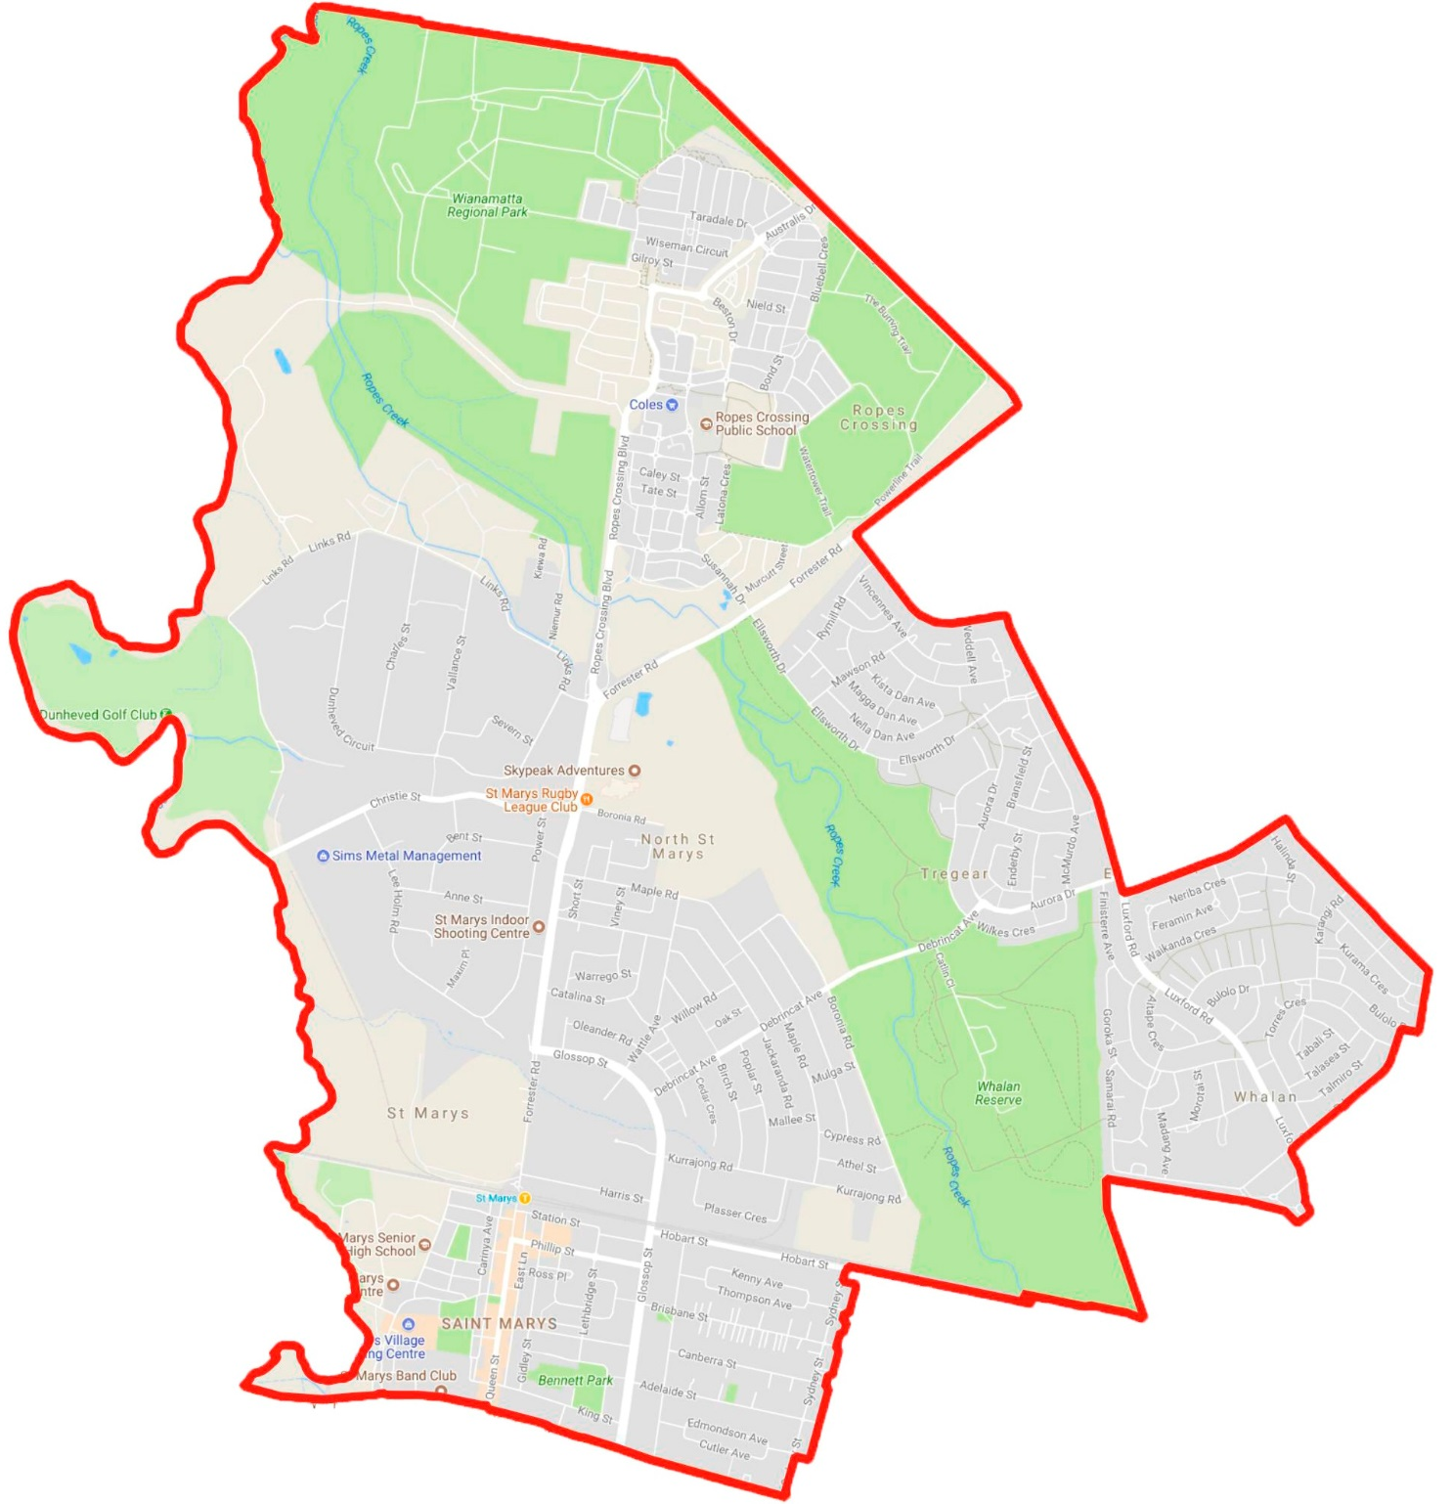
In accordance with the Department of Education Enrolment Policy, Chifley College Dunheved Campus has a responsibility to accept all students who reside permanently within our enrolment areas as defined by the DoE.
Required Documentation for Enrolment
Every new enrolment must have:
- Original birth certificate or passport;
- Proof of address; rate notice, rental agreement, paid utilities bill;
- Notice of assessment from the Intensive English Centre (if recently arrived in Australia);
- Any student who is not Australia or New Zealand citizen must have an appropriate residency visa or approval to enrol in accordance with conditions set by the Department of Immigration and Citizenship;
- Other relevant documents, such as Court Orders, AVO, etc;
- Most recent school report and NAPLAN results;
- Completed application to Enrol in NSW Government School form (provided in the school enrolment package)

Enrolment Process
- Enrolment interview, above listed documents will be collected and processed;
- School procedures and routines, The Dunheved Way (outlined in the Information Book) will be discussed;
- Appointment arranged for student to complete diagnostic testing (Chifley College Dunheved Campus Learning and Wellbeing Hub)
- The Principal / Deputy Principal will explain the DoE procedures which must be followed, including the completion of the Application to Enrol in a NSW Government School form and request for information from the previous school enrolled;
- The Principal / Deputy Principal will send a Request for Information form to the student’s previous school to check on history of violent behaviour or learning support needs. If necessary, a Risk Management Plan will be prepared and discussed with staff, before enrolment is finalised;
- If necessary, DoE personnel (student wellbeing, learning support) will be contacted regarding additional support required. Any health issues (eg anaphylaxis, diabetes) must be addressed by the development of a personal health plan before enrolment;
- All forms must be returned to the School Administration Office and data entered;
- Student timetable generated (in general, the enrolment process will require 2-3 days for completion); and
- Administration staff will establish a student file, check documents and update ERN.

International Students
International fee paying students may apply for enrolment at this school. Their applications must be made using the NSW Government Schools International Student Application Form through the International Students Centre. The Centre is responsible for the verification of status of International students. The school will consider these applications in light of the availability of places.

Students with a history of violence seeking enrolment (Legal Bulletin 40)
Violence is defined but not limited to: “any behaviour (physical or other) which seriously interferes with the physical and psychological safety and wellbeing of staff and students.
For any such student:
- Staff are provided with all relevant information available. Cases and their facts will differ.
Staff likely to be affected include SASS, integration SLSO’s, permanent teaching staff and casual staff.
- Staff are briefed on the student’s personal information to the extent necessary to protect the health and safety of people at the school. For example, the history of a child’s development or personal crises in the student’s life may not be relevant, but the manifestations through the student’s behaviour will be.
- The Enhanced Enrolment process will be utilised if needs be.
- Regional support staff may be required to manage any impasse where approvals are not granted or where documentation is incomplete or not received. Enrolment MUST NOT proceed until any matters of past records and necessary risk management are resolved and issues concerning the safety of staff and other students are addressed.

Once records are received, risks are identified and assessed. Counsellor transmitting of relevant information to the Principal occurs to support this process. Staff MUST be consulted at all stages of the risk assessment process. This is especially those staff whose safety may be affected by decisions concerning the risks and how the risks are to be
managed. This typically requires a behaviour management plan to be compiled consultatively with the teaching and support staff who will be teaching or who will have close contact with the student. Regional support may also be required.

Presenting information in terms of a risk management will present the risks realistically and strategically. Privacy for the student concerned needs to be upheld outside of those concerns impacting on Occupational Health and Safety matters. Reviewing the risk management once enrolment commences is a critical concern.

Appeal and review
Where a parent wishes to appeal (within 10 days) against the decision of the placement panel, the appeal should be made in writing to the Principal. Where required, the Principal should provide or arrange assistance, such as an interpreter, to enable the appeal to be set out in writing. The Principal will seek to resolve the matter.

If the matter is not resolved at the local level, an appeal may be lodged in writing to the Director, Educational Leadership who will consider the appeal and make a determination.

Chifley College Dunheved Campus enrolment information and procedures discussed and ratified on _______________________

Mrs Jennifer Ribeiro
Principal
Chifley College Dunheved Campus

